COSC326 Étude 12:

Dropping Cars Report

Task

Your stunt team is tasked with exploring the feasibility of propelling a car off a towering 100-storey building, with the added requirement that the car must be operational upon landing. To meet this challenge, the selected vehicles necessitate meticulous preparation to reinforce their chassis and ensure the safety of the driver. Each car acquisition will incur a price tag of $14,999, while each test conducted (consisting of dropping a car from a specific storey) will amount to $6,138 in expenses.

The feasibility study involves finding the best worse case in terms of attempts and price for a 100-storey building and finally creating a generalised method for any storey building.

Question 1: Design a method that could determine the highest “safe” floor, assuming you have two cars to use in the tests. In the worst case, how many tests do you have to do?

At first we considered a binary search but quickly realised that with the limitation of only having two cars that can be dropped the exact safe floor couldn’t be found. From this realisation we knew we had to come up with a solution that uses the second car to determine exactly what floor the car can be dropped from and be driven safely away.

Our next solution was to take a linear approach by first dropping the car at the 10th floor and if it landed safely dropping the next car 10 floors higher than the previous drop. When the first car broke we knew what range of floors the car could be landed safely, the latest safe landing and the recent crashed test. This reduced the problem to just 10 floors. From there the second car can be dropped starting from the latest safe landing and slowly iterate up to the floor of the crashed test. Then we could pinpoint what exact floor the safe floor was on. In the worst case this would take 19 tests.

For example, say our first car safely landed at floors 10, 20, and 30 and then crashed at floor 40. We know that the highest safe floor must be between 30-39, so we can drop our second car from floor 31. If it crashes our highest safe floor is 30, otherwise, if it safely lands we go on to our next test at floor 32. We repeat this process until we discover our highest safe floor.

The problem with this previous method is that the higher up the safe floor is in the building, the higher our worst case gets. If the highest safe floor is 99 then our first car would be dropped 10 times, failing at the 100th floor and then our second car would have to be dropped 9 times, leading to a total of 19 times. To counter this problem we devised a solution that uses decreasing increments of the gaps of drops for car 1, meaning our second car has to do fewer drops the higher up the building the highest safe floor is.

Here is a table showing how our solution works and showing the worst case of attempts at each given increment height. Our 1st car we test with will continue tests from 14 then 27 etc and once it breaks, we use our 2nd car to test every possible floor from our last pass test with car 1 and most recent failed test with car 1. Car 2 will go up one floor at a time and if it breaks during any tests, we know that the test below where it passed is the highest safe floor possible for a stunt car to land and drive away from.

|  |  |  |
| --- | --- | --- |
| 1st car drop story | Sequence of 2nd car drop story if 1st car drop breaks | Total amount of drops (# of times 1st car dropped + # of times 2nd car dropped) |
| 14 | 1, 2, 3, 4, 5, 6, 7, 8, 9, 10, 11, 12, 13 | 1 + 13 = 14 |
| 27 | 15, 16, 17, 18, 19, 20, 21, 22, 23, 24, 25, 26 | 2 + 12 = 14 |
| 39 | 28, 29, 30, 31, 32, 33, 34, 35, 36, 37, 38 | 3 + 11 = 14 |
| 50 | 40, 41, 42, 43, 44, 45, 46, 47, 48, 49 | 4 + 10 = 14 |
| 60 | 51, 52, 53, 54, 55, 56, 57, 58, 59 | 5 + 9 = 14 |
| 69 | 61, 62, 63, 64, 65, 66, 67, 68 | 6 + 8 = 14 |
| 77 | 70, 71, 72, 73, 74, 75, 76 | 7 + 7 = 14 |
| 84 | 78, 79, 80, 81, 82, 83 | 8 + 6 = 14 |
| 90 | 85, 86, 87, 88, 89 | 9 + 5 = 14 |
| 95 | 91, 92, 93, 94 | 10 + 4 = 14 |
| 99 | 96, 97, 98 | 11 + 3 = 14 |
| 100 | No second car is needed, as the height the building reach can test can go no higher | 12 + 0 = 12 |

With this method we even out our worst case of attempts to be 14 through various floors of the building (the floor below any increment of car 1 drops). This method of using decreasing increments for our 1st car helps lower the worst case because the higher up the 1st car can go until it crashes, the fewer floors the 2nd car has to test. Our first car is used to shorten the range of which the highest safe floor can be and the second car goes through each floor within that range to find the exact highest safe floor. This method only has a worst-case of 14 attempts, to determine the highest safe floor.

Question 2: Does your method change if you are allowed more cars? Is it any cheaper in the worst case?

If we are allowed more cars, we would investigate a binary search algorithm because it’s much more efficient when it comes the amount of drops. Here is the breakdown of a binary search algorithm for a 100 storey building:

1. Determine the lowest and highest possible safe floor, e.g., initially this is floor 0 and floor 100.
2. Test the floor in between the lowest and highest possible floor, e.g., initially this is floor 50.
3. If it passes we repeat the process with the next lowest point being updated to the floor that was just tested, e.g., initially this is floor 50.
4. If it crashes we repeat the process with the next car and with the next highest point, e.g., initially this is floor 50.

To prove this we implemented both decreasing increments approach and a binary search approach into Java to generate data for all possibilities of the highest safe floor. From this data, we were able to graph both solutions to compare the solutions and show which one would be better in terms of attempts and price in a worst-case scenario.

In every case, our binary implementation leads to 7 attempts, but our incremental method averages 10.38 tests per case. This makes our binary implementation a much more consistent method (time-wise) for our stunt team.

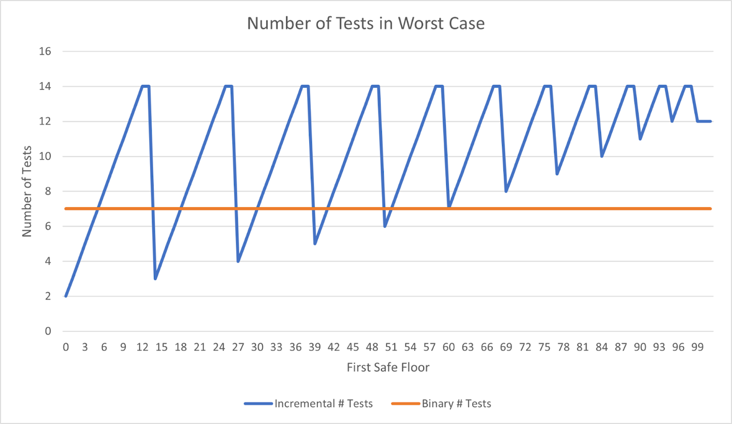

Cost-wise the binary method is slightly more expensive on average, with an average cost of $93,168 versus $91,530 on average for the incremental method. The binary method is not better in the worst case, with a worst case of $147,966 vs $115,944 for the incremental method.

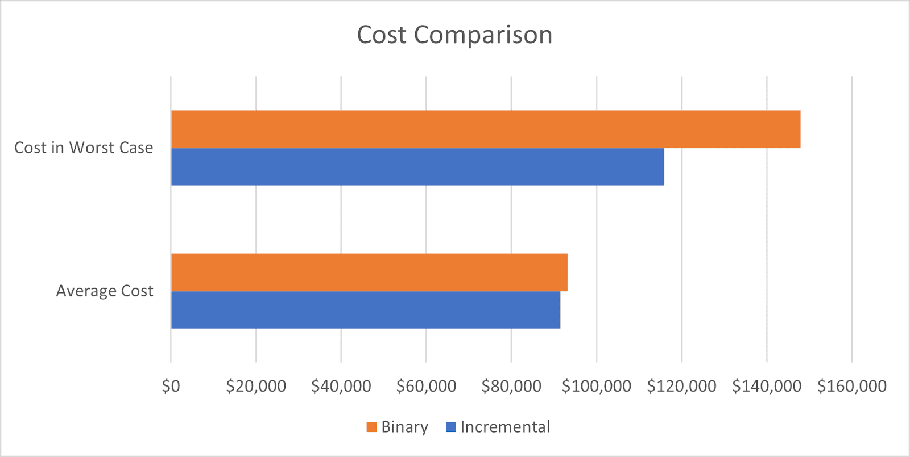

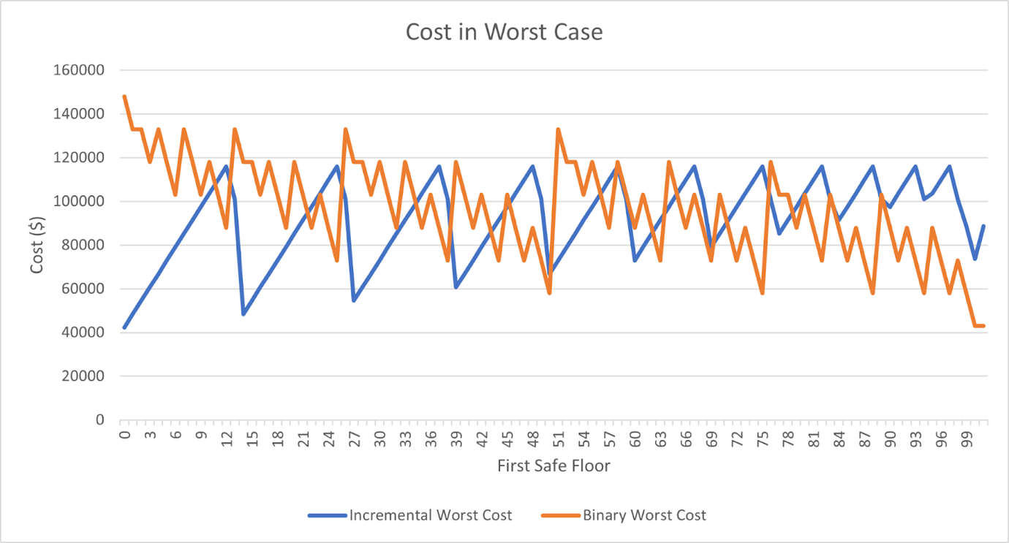

**Here is the breakdown of the cost the worst-case scenario using binary search:** Assuming every car keeps breaking at every test and the highest safe floor is at floor 0

Price of each car used = $14,999

Price of each test = $6,138

Amount of tests = 7

Amount of cars used = 7

Cost of Total Cars = 7 x $14,999 = $104,993

Cost of Total Tests = 7 x $6,138 = $42,966

Total Cost (worst case) = $104,993 + $42,966

Total Cost (worst case) = $147,959

Here we keep dropping the car from half of the known range to the highest safe floor can be. Therefore each test we half the problem until we are only left with one possible floor it can be.

**Here is the breakdown of the cost of the worst-case scenario using a decreasing increment approach:**

Amount of tests = 14

Amount of cars used = 2

Cost of Total Cars = 2 x $14,999 = $29,998

Cost of Total Tests = 14 x $6,138 = $85,932

Total Cost (worst case): = $29,998 + $85,932

Total Cost (worst case): = $115,930

Here we can see that our decreasing increments approach using only two cars is still a cheaper alternative compared to a binary search approach by over $30,000. In terms of attempts, however, a binary search halves the worst case of the number of tests needed to only need 7 tests to work out the highest safe floor possible for a stunt car to land from and drive away.

Question 3: Assuming the costs given above, generalise your method so that, for a given height, you can determine the cheapest strategy.

Assuming the costs given above, generalise your method so that, for a given height, you can determine the cheapest strategy.

While binary search is better in efficiency and reduces the number of tests. Our decreasing increment approach still holds optimal from a price point. To generalise our increment approach we can write it as the equation.

Height of Building

here is the first drop of our very first car. From there the method stays the exact same for any given building height example. The following increments in the car lands safely from the test will be x+(x-1). However, if the test cars the next car will go through every floor between the last successful test and the recent failed test heights one by one to find the exact highest safe floor. So once you solve for x you can follow the exact method provided in Question 1.

Now let's solve for :

We can turn the equation above into a quadratic formula to solve for (let's show this working with a 100-storey building)

Multiply both sides by 2 to get rid of the “”:

Expand the brackets:

Make the quadratic equal to 0:

Solve for x:

Since we cannot have a negative floor we will use the 13.651 answer. Rounding to 14.

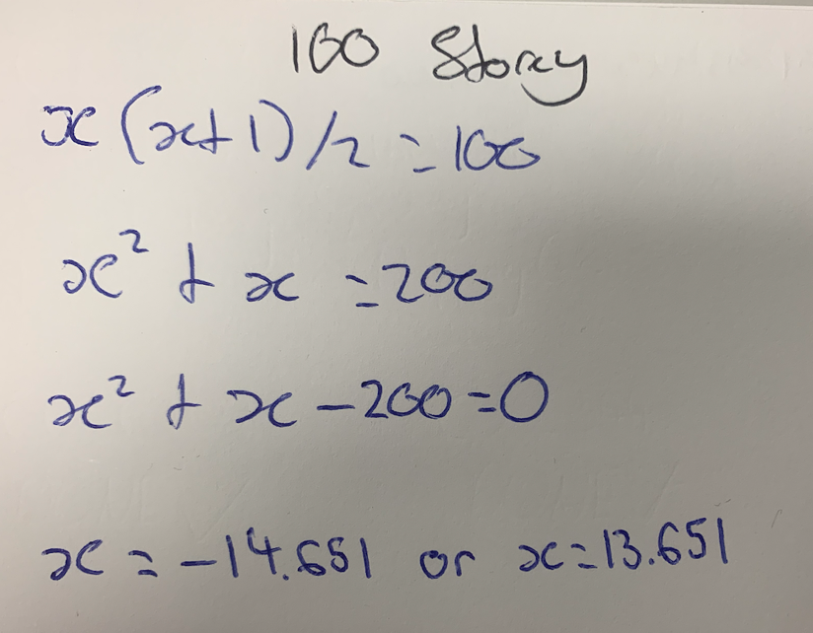

Now we have our car's first drop point, we go and use our other equation to find the next floor we drop that car from if it passes. For example, if our first car passes the test at 14 for a given 100-storey building we would solve by:

Since :

Next floor to test car one at = floor 27

However for example, if the first car crashed at floor 14, our 2nd car would start at floor 1 and continue going up by one until we can find the exact highest safe floor. This will be known from the tests car 2 takes by finding the highest floor it lands safely at and drives away.

I.e. if it lands at floor 1 and crashes at floor 2 afterwards; we know floor 1 is our highest safe floor to report to the stunt team.

The generalised equations of Height of Building to solve for our first tests floor and to solve the next floor after that to drop a car at together help generalise our solution for any given storey building our stunt team will come across in any production of a movie.

Question 4: Imagine the building is only 92 storeys. How much might it cost? How many cars do you need?

Imagine the building is only 92 storeys. How much might it cost? How many cars do you need?

Using our generalised equation shown in Question 3, we can use the formula x(x+1)/2 to solve for our first test floor by plugging in the given height of the building (92 floors)

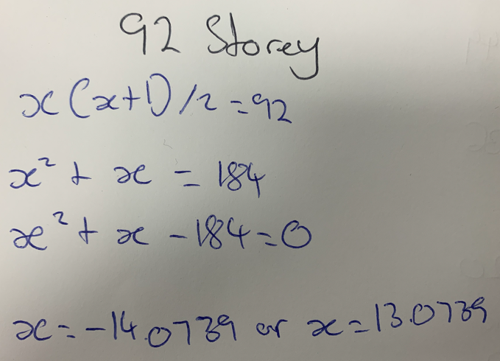

Multiply both sides by 2:

Expand the brackets:

Set quadratic equal to 0:

Solve for x:

From this, we know to drop our first car from floor 13 and then continuously go up in increments of , or in the example of this question; which turns out to be 25. If our first car breaks at any point the second car we use will go up one by one from the last pass test floor and the recently broken test floor to find the exact highest safe floor.

Here is a drawing we did to show all the increments in a 92-storey building:

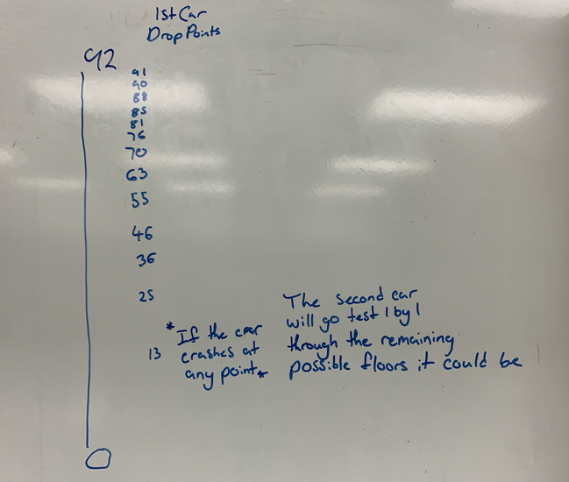

In the worst case, this method would cost $109,792 with the use of only two cars being used throughout the tests.

There are many possible worst-case floors which give this cost but let's use 11 as an example.

Our first car would be dropped from floor 13 and it would crash, costing us:

$14,999 + $6,138 = $21,137

Our second car would then start at floor 1 and keep testing the floor right above until it crashes at floor 12. Meaning that we found floor 11 is our highest safe floor, and this cost us:

$14,999 + ($6,138*12) = $88,655

Together that comes to a total cost of:

$21,137 + $88,655 = $109,792

Here is a breakdown of the cost of the method at any possible highest safe floor:

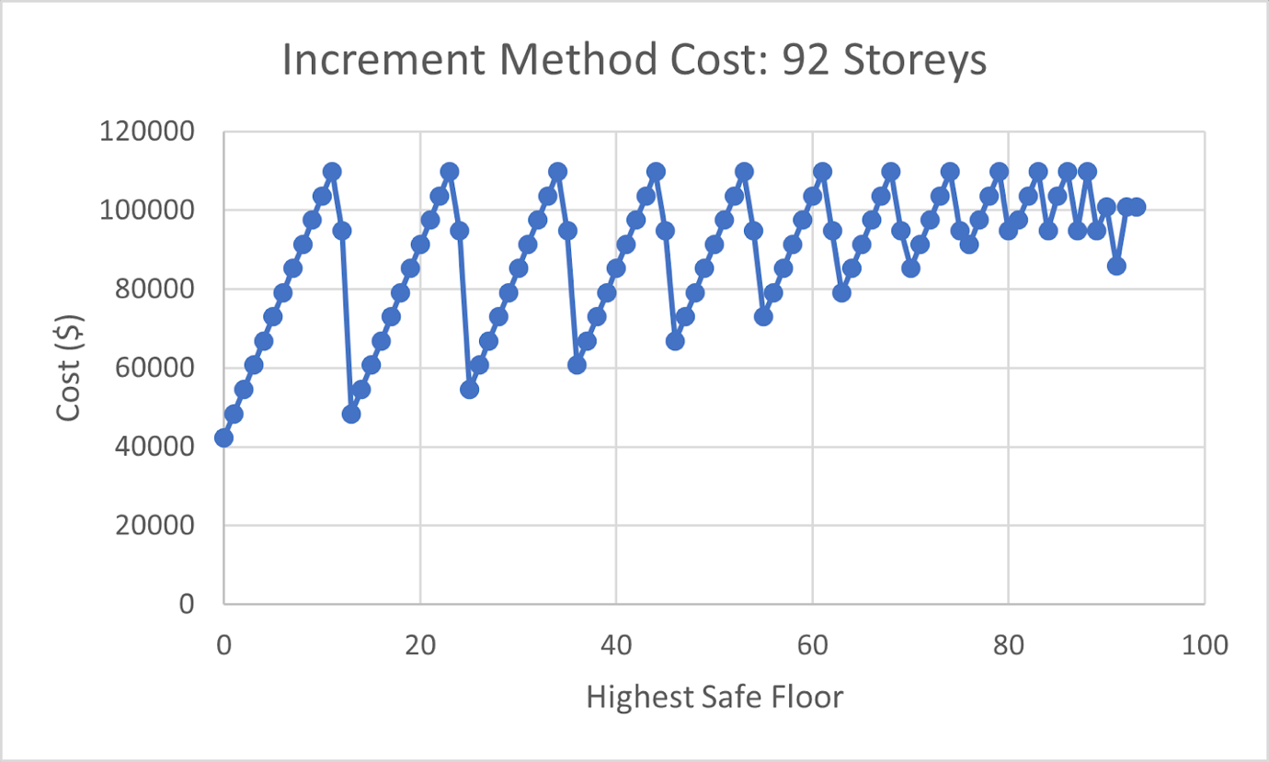

Our Decision

In conclusion, after comparing various car dropping methods, our stunt team has decided to use the “increment” approach defined in Question 1. We believe this is the best decision for us because it is both scalable and cheap, allowing us to soar to new heights.